Preliminary Design Report

**Nuclear-Thermal Propulsion**



**Presented by ….**

**Team Xplorers**

**Table of Contents:**

1. Team information………………………………………………………3
2. Introduction……………………………………………………………….4
3. Mission profile……………………………………………………………6
   1. Mission statement………………………………………..6
   2. Mission constraints……………………………………….6
   3. Timeline………………………………………………………..6
   4. Launch summery…………………………………………..7
   5. Project budget………………………………………………9
4. Mission trajectory……………………………………………………….9
   1. Transfer orbit selection…………………………………9
   2. Analysis for efficient launch…………………………..9
   3. Mission sequence…………………………………………10
   4. Selection of trajectory………………………………….10
   5. Simulations on GMAT…………………………………..12
   6. Calculations of ΔV through trajectory equation.12
5. Nuclear fuels……………………………………………………………...15
   1. Selection criteria……………………………………………16
6. Propellant………………………………………………………………….19
   1. Selection criteria…………………………………………..19
   2. Mass approximation……………………………………21
7. Storage……………………………………………………………………21
   1. Material selection………………………………………22
   2. Cryogenic storage technology……………………22
8. Structures………………………………………………………………..24
   1. Material selection for spacecraft bus………….24
   2. Nozzle………………………………………………………….25
   3. Engine cycle………………………………………………….25
9. Thermal control……………………………………………………….26
10. Conclusion……………………………………………………………27
11. References…………………………………………………………….

**List of Figures:**

**1. Team Information**

Team name: Xplorers

Mentor name:

Team members:Manav Gupta (Team Leader)

* R. Bhuvan
* R.S Deepamangala
* Tushar
* Aravind Nagesh
* Rohini
* Yashodha SM
* Snehal
* Urvi Palang
* Neha Yadav

**2. Introduction**

Nuclear thermal propulsion is fundamentally a new capability with huge scope for further research. In this type of propulsion energy comes from fission of radioactive fuel. The fundamental capability of Nuclear Thermal Propulsion (NTP) is game-changing for space exploration. A first-generation Nuclear Cryogenic Propulsion Stage (NCPS) based on NTP could provide high thrust at a specific impulse above 900 s, roughly double that of state-of-the-art chemical engines. To demonstrate the significance of high Isp let us look at rocket eq.

Δ𝑽=𝑰𝒔𝒑∗ 𝒈𝟎∗𝐥𝐧(𝒎𝟎/𝒎𝒇)

with ΔV being the change in velocity of a spacecraft necessary to travel to a destination, Isp being the ratio of thrust to weight of fuel consumed, g0 being Earth’s gravitational acceleration (9.81 m/s^2), m0 being the initial mass of the craft before a burn, and mf being the final mass of the craft after a burn. In order to alter orbits and ultimately travel between moons, planets, and stars, there is always a certain delta-V required. There is an exponential relationship between mass and delta-V, and as delta-V requirements increase, the mass of fuel needed to meet those requirements increases exponentially. An increase in Isp leads to an exponential decrease in the mass of fuel required and hence the weight of the system. For interplanetary mission durations, high thrust systems can provide shorter mission durations than low thrust systems for the same delta-V. while electric propulsion can provide us with high Isp it has very low thrust, NTP can help in this aspect by providing a balance of high Isp and relatively high thrust hence reducing travel time and also enabling carrying large cargo. According to one estimate, nuclear propulsion has the potential to reduce the travel time to Mars by 20-25%. Additionally, the higher fuel efficiency by weight gives much more flexibility to any potential Mars missions, including the ability to launch during a broader ranch of times. Currently, launch windows are highly limited by the relative orbital positions of the Earth and Mars, but a nuclear thermal rocket could carry enough fuel for a long journey. Finally, the efficiency gains also could reduce mission costs significantly. Any type of rocket, once reaching low earth orbit, will likely need to be refuelled by an additional rocket before embarking on the journey to Mars. The cost of refuelling would be lower for a nuclear thermal rocket since a much lower amount of fuel is needed. An unmanned NTP mission could be used to carry cargo and infrastructure required for setup of a future human colony on mars.

In our mission, we are using NTP for unmanned mission in order to check the feasibility of such a mission to carry the cargo necessary for space settlements in future. We have chosen this mission as the higher Isp will reduce the fuel cost and also give us a wider range at the launch window. The high thrust will also be beneficial for carrying heavier cargo. This can be used as a technology demonstration for any future manned missions to Mars.

The problems faced by NTP currently are due to the need for some more research and hence technological advancement in terms of improving its efficiency even further and reducing cost. Also, the measure challenge is environmental and health hazards due to the emission of harmful radiation waste.

**3. Mission Profile**

**3.1. Mission Statement**

To design a nuclear thermal propulsion rocket for an unmanned mars mission

**3.2. Mission Constraints**

Due to environmental and safety issues, Nuclear propelled missions cannot be launched from the ground. Hence our mission will be launched from the ground to the higher earth orbit (HEO) using available liquid-propelled launch vehicles. Our propulsion system will start working from the HEO.

**3.3. Timeline**

|  |  |  |  |  |
| --- | --- | --- | --- | --- |
| **Phase** | **Date** | **Event** | **Detail** | **Result** |
| [**Geocentric**](https://en.wikipedia.org/wiki/Geocentric_orbit)**phase** | 30 November 2028 09:00 UTC | Launch | Burn time: -x min in x’ stages | Apogee: 250 km (155 mi) |
| 30 November 2028 | [Trans-Mars injection](https://en.wikipedia.org/wiki/Trans-Mars_injection) | Burn time: x sec | [Heliocentric](https://en.wikipedia.org/wiki/Heliocentric_orbit) insertion Apogee: -7000 km (4,349 mi) |
| [**Heliocentric**](https://en.wikipedia.org/wiki/Heliocentric_orbit)**phase** | December 2028 – September 2029 | This phase plan included up to 3 trajectory corrections if needed. | | |
| 14 December 2028 | 1st Trajectory correction  (planned) | Burn time: x sec | Major course correction to direct the probe to Mars |
| [**Areocentric**](https://en.wikipedia.org/wiki/Areocentric_orbit)**phase** | 29 September 2029 | Mars orbit insertion | Burn time: x sec | Achieve a stable elliptical Mars trajectory |

Table.1 Mission Timeline

**3.4. Launch summary**

The maximum thrust that a nuclear rocket can generate for a given weight is lower than that of a chemical rocket. In fact, a nuclear engine cannot generate enough thrust to overcome the Earth's gravity at launch, at least given existing technology. Therefore, from a performance perspective, chemical engines are necessary for escaping the Earth's atmosphere, but nuclear engines are optimal once a space vehicle is in low earth orbit. Also in the earth’s atmosphere launching a nuclear-powered spacecraft can prove to be harmful for both nature and pose a health hazard to the community. It will also pose some issues getting clearance from a government organization.

We will therefore use an existing launch vehicle for carrying our system to HEO. We have decided to use **falcon heavy** for its immense capacity to carry payload.

**Launch vehicle details**

Table.2 Launch vehicle details[6][7]

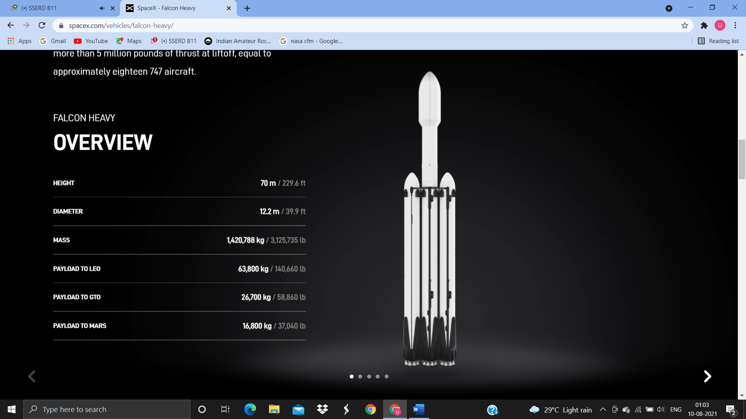

Fig.1 Falcon Heavy Launch Vehicle[6][7]

**Payload carrying module dimensions**

|  |  |
| --- | --- |
| Height | 13.1m |
| Diameter | 5.2 m |

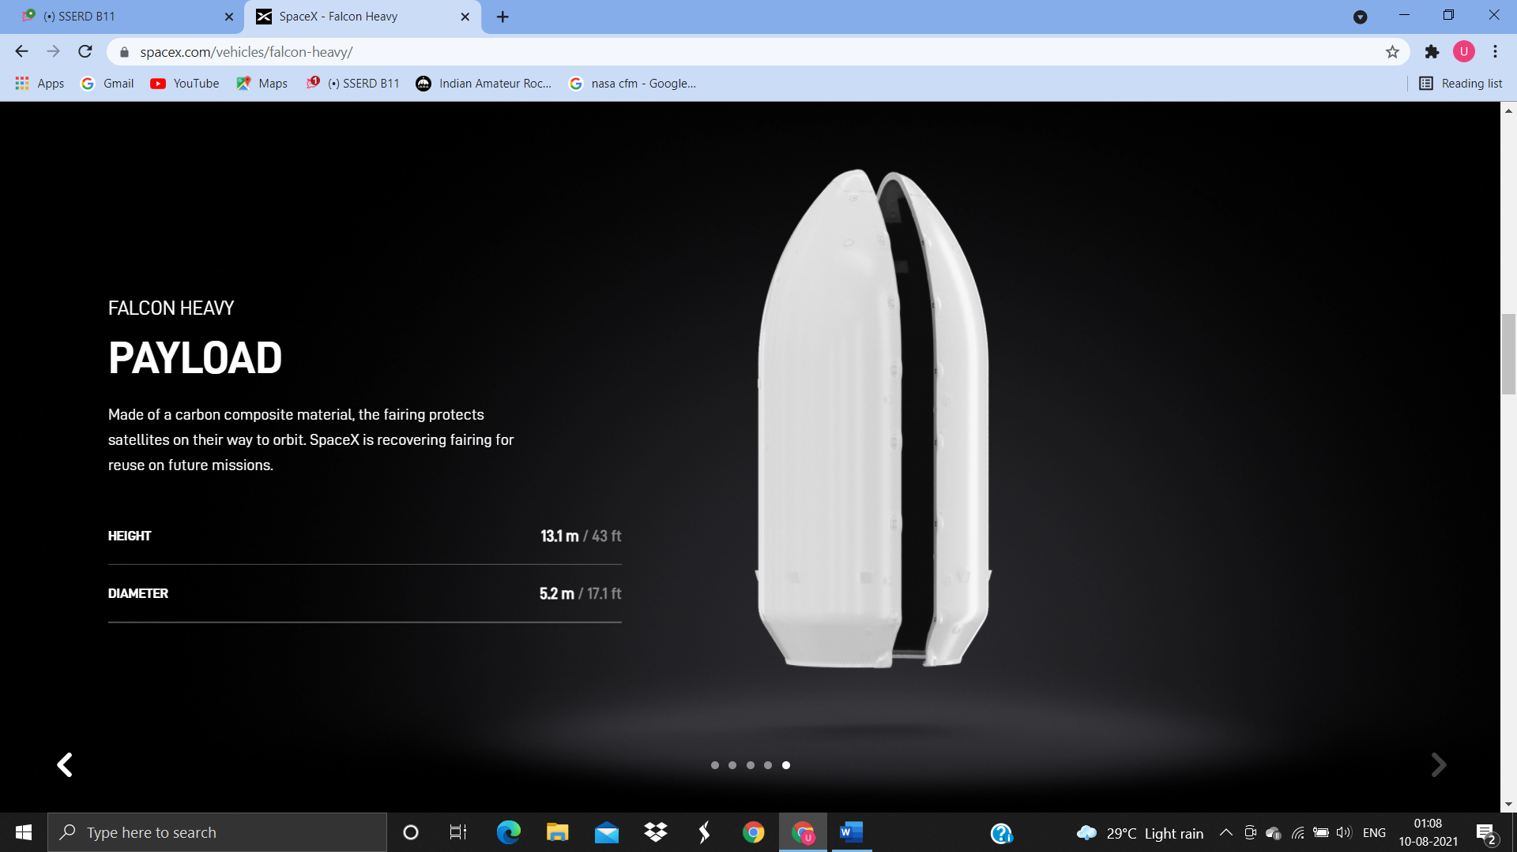

Table.3 Payload Module Dimensions[6][7] Fig.2 Payload Module[6][7]

**3.5. Project budget**

The Nuclear thermal Propulsion rocket will be carried as a payload aboard the SpaceX Falcon Heavy. It will be transferred from Earth to the Geostationary Transfer Orbit (GTO)

The cost details are as follows:

|  |  |  |
| --- | --- | --- |
| S.No. | Parameter | Cost (USD) |
| 1. | Launch cost | 90 million (Reusable)  150 million (Expendable) |
| 2. | Developmental budget | 20 billion |
| 3. | Program Cost | Tens of billions of dollars |

Table.4 Project Cost Details[6]

Due to inflation by the time the program is carried out, the following contingencies are considered:

1. Launch cost (5%) = 4.5 million USD (Reusable)

7.5 million USD (Expendable)

2. Developmental budget (20%) = 4 billion USD

The cost model being followed for the program is the European Space Agency (ESA) model.

The total cost of the entire program will be tens of billions of dollars.

**4. Mission trajectory**

**4.1. Transfer orbit selection**

We had decided to go with Type 2 Transfer as it is the most fuel-efficient (but slowest) way to go to Mars. Choosing the slowest route with the NTP system seems contradictory as nuclear propulsion is originally designed for faster space travel. However, we are planning for an unmanned mission. Hence, reduction of cost-per-kg of the payload is in our concern and not the time duration.

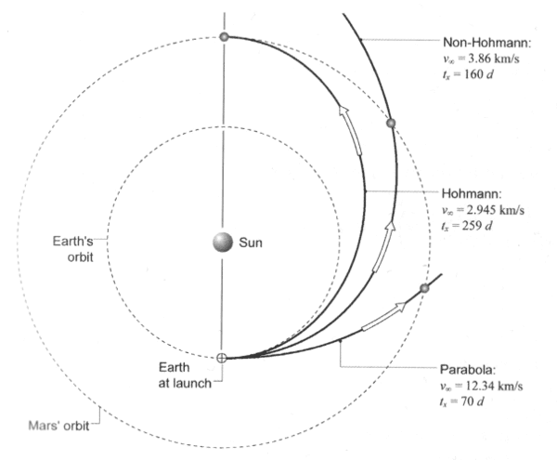

Fig.3 Transfer Orbit to Mars

**4.2. Analysis for efficient launch**

* Most of the interplanetary missions that had happened for Mars involved trans-mars injection through a highly elliptical orbit at perigee which happens to be at the altitude of within 200km. Initially, for the NTP system, we were planning for a launch from HEO. Later we realized that as we go higher from the earth’s surface, the velocity of the spacecraft would substantially decrease requiring a large amount of delta v for Hohmann Transfer.
* A better idea would be to escape Earth with the chemical systems (conventional method). Later, perform jettison to separate chemical chamber and proceed in HO with Nuclear Thermal Rocket and ultimate payload. Now the course corrections during the transit and Mars orbit injection could be performed with nuclear systems.

**4.3. Mission Sequence**

**Nuclear Thermal Propulsion**

1. Transfer Correction Manoeuvres (at different points of HO)
2. Mars Insertion Manoeuvre near periapsis (to get in elliptical orbit)

**4.4. Selection of Trajectory**

* There were many HTO that could be taken but like any other mission, we have to search for the optimum and efficient route amongst all possibilities.
* An orbit that traverses less than 180° around the primary is called a "Type I" Hohmann transfer, while an orbit which traverses more than 180° is called a "Type II" Hohmann transfer.

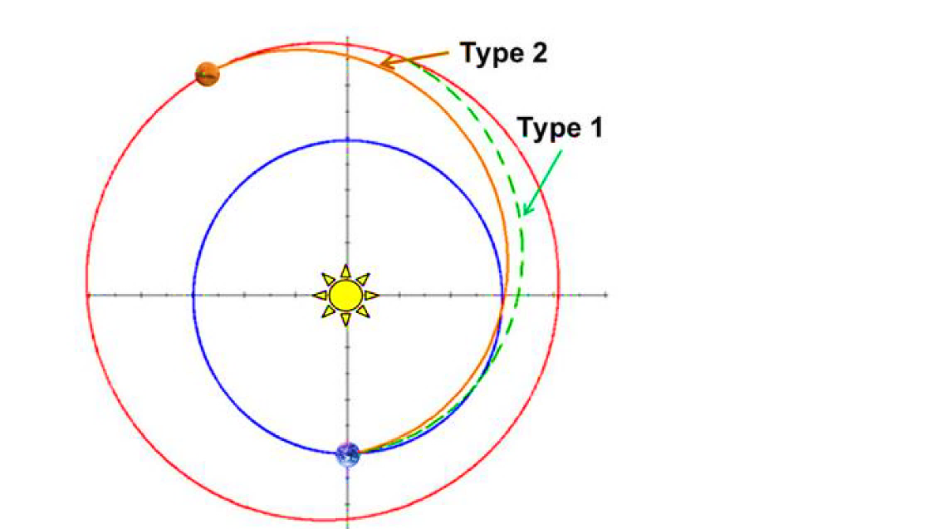

Fig.4 Hohmann Transfer Orbit Types

* With the help of the “*Porkchop”* plot from the years 2028 to 2033 (ideal for our mission), we found two trajectories with each reducing duration and $∆V$ individually.

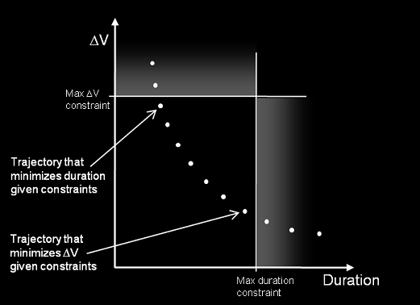

Fig. 5 $∆V$ vs Time for Transfer Orbit

* However, we preferred a lower $∆V$ over time for reasons already discussed. This happens to be within the launch window occurring in

November, 2028 – December, 2028. It’s through a Type 2 HTO.

**Type 2 Transfer (304 days transfer)**

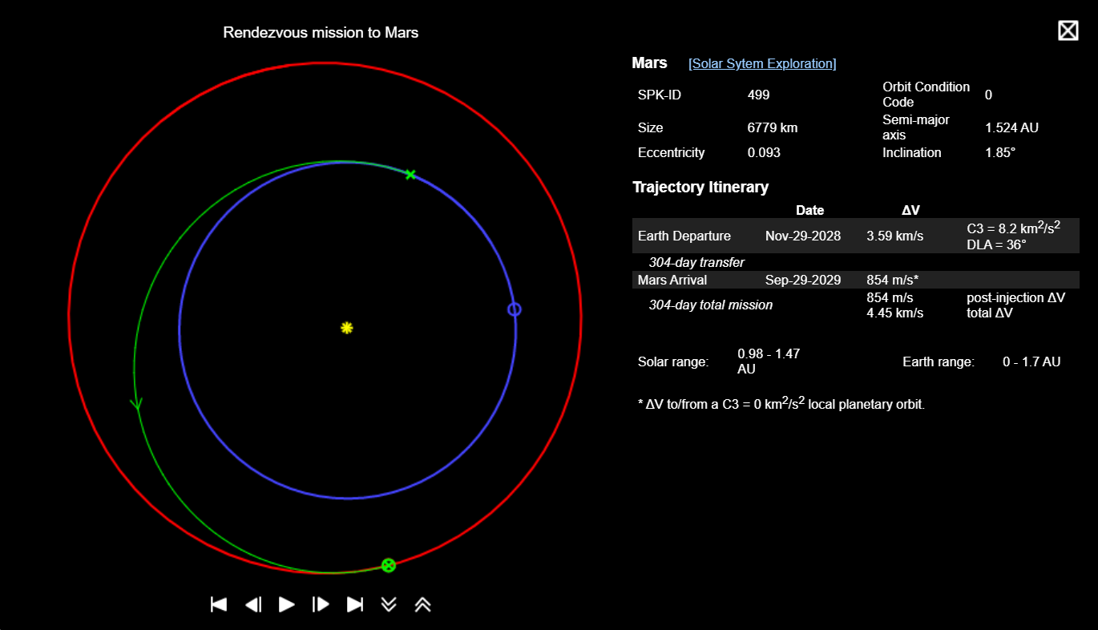

Fig.6 NASA’s Trajectory Browser

* The mission as per plans and through data inferences from NASA’s *Trajectory Browser* is supposed to make its launch on November 29, 2028. It will be a 304-day transfer.
* The mission would require a very low amount of $∆V=(0.854 km/sec)$ during Mars Injection Phase, making the overall cost lower.
* At Earth departure:

$$∆v=3.59 km/s$$

Adding contingency (5%):

$$∆v=3.7695 km/s$$

$$∆v=3.59+0.1795$$

$$∆v=3.7695 km/s$$

* Mars Insertion:

$$∆v=0.854 km/s$$

Adding contingency (5%):

$$∆v=0.854+0.0427$$

$$∆v=0.8967 km/s$$

$$∆v=0.8967 km/s$$

**4.5. Simulations on GMAT (General Mission Analysis Tool) NASA**

We had performed various simulations in the software taking into account: -

* Orbital Parameters in Keplerian Model
* Impulsive Burn Maneuvers in all scenarios
* Gravitational Model of Earth, Mars, and Sun

We calculated $∆V=1.2 km/sec$ through simulations which is larger than NASA’s $∆V=0.854 km/sec$.

The reasona are supposed to be the lack of accuracy in orbital data considerations.

**4.6. Calculations of $∆V$ through trajectory equations**

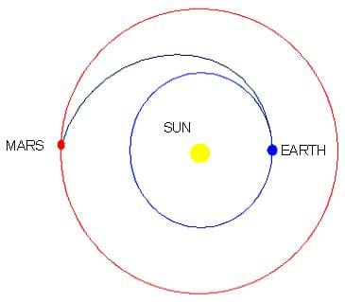

Fig. 7 Heliocentric Orbit Transfer

Let the distance between Sun and Earth be r1 and the distance between Sun and Mars be r2.

Let the spacecraft move around the Earth at velocity of v1. We need to fire to change velocity from v1 + Δv1. To get Mars orbit, the velocity must be v2. We need to give Δv2, so that we can match the speed of Mars.

By Hohmann Transfer, we take elliptical path.

Let **a** be the semi major axis of transfer orbit.

$$a=\frac{r_{1}+r_{2}}{2}$$

$$r_{1}=1 AU and r_{2}=1.52366 AU$$

$$a=\frac{1+1.52366}{2}$$

$$a=1.26183 AU$$

**Formula to find velocities v1 and v2:**

Where,

M = mass of the sun

r1 = radius measured in metres

$$v_{1}=\sqrt{\frac{1.327*{10}^{20}}{1.496*{10}^{11}}}$$

$$v_{1}=2.9783*{10}^{4}m/s$$

$$v_{2}=\sqrt{\frac{μ}{r_{2}}}$$

Where,

$$μ=GM$$

M = mass of the sun

r2 = radius measured in metres

$$v_{2}=\sqrt{\frac{1.327*{10}^{20}}{2.2793629*{10}^{11}}}$$

$$v_{2}=2.4128*{10}^{4} m/s$$

**Finding Δv:**

$$∆v_{1}=\sqrt{\frac{GM}{r_{1}}}\left(\sqrt{\frac{2r_{2}}{r_{1}+r_{2}}}-1\right)$$

$$∆v_{1}=\sqrt{\frac{μ}{r_{1}}}\left(\sqrt{\frac{r_{2}}{a}}-1\right)$$

$$∆v_{1}=\sqrt{\frac{1.327*{10}^{20}}{1.496*{10}^{11}}}\left(\sqrt{\frac{1.52366}{1.26183}}-1\right)$$

$$∆v_{1}=2.94 km/s$$

$$∆v_{2}=\sqrt{\frac{GM}{r_{2}}}\left(1-\sqrt{\frac{2r_{1}}{r_{1}+r_{2}}}\right)$$

$$∆v_{2}=\sqrt{\frac{μ}{r_{2}}}\left(1-\sqrt{\frac{r_{1}}{a}}\right)$$

$$∆v_{2}=\sqrt{\frac{1.327*{10}^{20}}{2.2793629*{10}^{11}}}\left(1-\sqrt{\frac{1}{1.26183}}\right)$$

$$∆v_{2}=2.6487 km/s$$

**Velocity at perigee:**

$$v_{p}=v_{1}+∆v_{1}$$

Where,

$$v_{p}=velocity at perigee$$

$$v_{p}=29.783+2.94$$

$$v_{p}=32.723 km/s$$

**Velocity at apogee:**

$$v_{a}+∆v_{2}=v_{2}$$

Where,

$$v_{a}=velocity at apogee$$

$$v_{a}=24.128+2.6487$$

$$v_{a}=26.7767 km/s$$

**5. Nuclear fuel**

Material which can undergo either fission or fusion reaction in a reactor chamber can be considered as a source of nuclear energy. Radioactive material which naturally undergo nuclear decay are also a great source of energy to utilize. For the propulsion system which we will use, fissile material that can undergo a sustained chain reaction which releases tremendous amount of energy in a controlled manner will be used. Uranium 235, a radioactive isotope of uranium is the best source of nuclear energy since, it readily absorbs neutrons and decays into two lighter elements releasing two to three more neutrons and thus create a sustained chain reaction. This material has been extensively mined and used in thermal nuclear reactors for electricity production in the industry. But naturally mined ore of uranium does not have enough U235 isotope (~0.7%) and thus have to undergo enrichment process (artificially increasing U235 concentration).

For NTP applications, fuel elements made of uranium have to contain high concentration of U235 (~93%)[4]. A solid core nuclear reactor reaching temperatures of up to 3000K is required to heat the propellant and eject them at high velocities. Different classification of uranium-based fuels, namely graphite-based fuels (uranium carbide in C) and metal alloy based fuel (uranium oxide/nitride in metal matrix) exist from which we have to select an appropriate fuel that can fulfill the requirement of the NTP reactor.

**5.1. Selection criteria**

Desired qualities of nuclear fuels used for NTP can be identified as followed:

* High melting point (>3000K)[4].
* Ability to withstand high thermal shocks.
* Low mass loss of fuel products.
* Thermal Stability (low mass loss by vaporization)
* High fuel density for compact reactor design.
* Ease of fabrication with current technology.

Over the years, many fuels have been analyzed and tested for NTP applications like the NERVA/Rover program from 1955 to 1972, Particle Bed System (SNTP), Cermet Fuel System, etc.

A list of fuels tested in the above-mentioned programs are given below.

|  |  |  |
| --- | --- | --- |
| **Concept/Program** | **Fuel composition** | **Fuel geometry** |
| Rover/NERVA | UC2 in graphite  (U, Zr) C, graphite (composite)  (U, Zr) C, solid solution | Solid blocks with coolant channels |
| PBR | Coated UC2  Binary, ternary carbides | Particle |
| CIS | Coated (U, Zr, Nb) C  (Other ternary carbides)  Carbonitrides | Twisted ribbon |
| Cermet | UO2 in W | Solid blocks with coolant channel |

Figure.5 NTP Application Fuels Description[4]

Selection of the fuels from this list was done on based of the available data of these concepts/programs. PBR fuels had high temperature potential but fabricability of the fuels were not developed completely along with extensive cracking at high temperatures and limited reactor experience. Thus, near term application of this fuel was not feasible. CIS fuels of mixed carbides was promising with initial data but no extensive data available and would require collaboration with Russians for further development.

Finally, Cermet fuels of uranium oxide in tungsten matrix has better safety features with bimodal or surface power operations, but for unmanned mission we are going with (U, Zr) C, graphite composite which went the most tests under the NERVA/Rover program with the most experience in reactor testing with highest operation time of 109 minutes. The graphite material also works as a moderator and reflector which can reduce us of an external material for reaction rate control[3]. This fuel has higher melting point that UO2-W fuel although it also experiences cracking issues at high operating temperatures and carbon mass loss within tolerable range. Ease of fabrication is also another factor with available data to rely on. Hence, our fuel selection for the mission will be (U, Zr) C, C composite fuel.

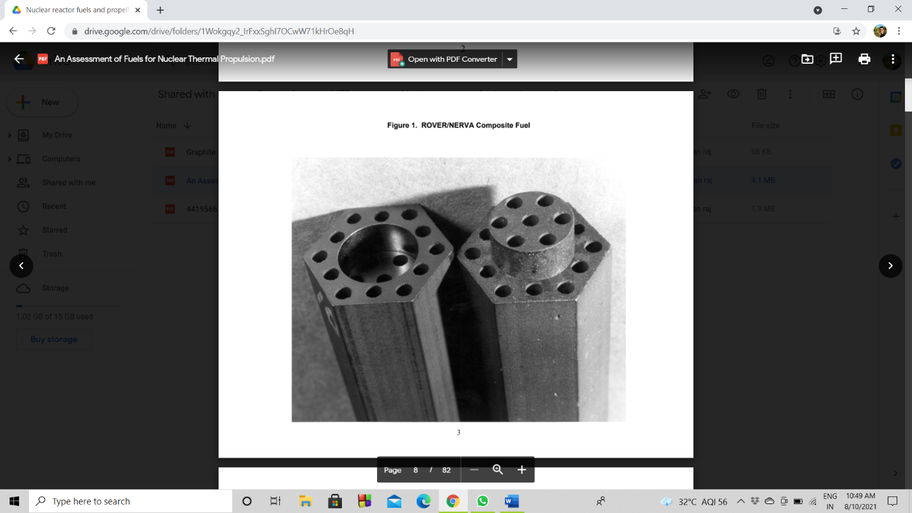

Fig.8 ROVER/NERVA Composite Fuel[4]

The test results of the ROVER/NERVA are as follows:

|  |  |  |  |  |  |  |
| --- | --- | --- | --- | --- | --- | --- |
| Reactor ID | Chamber Temperature (K) | Fuel Exit Temperature (K) | Space Equiv. ISP (sec) | Time at full power (min) | Fuel Type | MWt/Thrust(kN) |
| KIWI-B4D | 1890-2130 | 2222 | 780 | 1 | UO2/Graphite | 914/204 |
| KIWI-B4E | 1890-2100 | 2389 | 820 | 8, 2.5 | UC2/Graphite | 914/204 |
| NRX-A2 | 2090 | >2200 | 775 | 3.4 | UC2/Graphite | 1100/245 |
| NRX-A3 | 2244 | >2400 | 820 | 16.3 | UC2/Graphite | 1100/245 |
| PHOEBUS-1A | 2366 | 2478 | 835 | 10.5 | UC2/Graphite | 1340/298 |
| NRX-A4 (NRX-EST) | 2264-2290 | >2400 | 820 | 28.6 | UC2/Graphite | 1100/245 |
| NRX-A5 | 2280-2333 | >2400 | 820 | 29.6 | UC2/Graphite | 1100/245 |
| PHOEBUS-1B | 2222-2290 | 2445 | 828 | 30 | UC2/Graphite | 1340/298 |
| NRX-A6 | 2300-2405 | 2556 | 847 | 62.7 | UC2/Graphite | 1100/245 |
| PEWEE-1 | 1835 | 2550  2750 | 845  890 | 43 | UC2/Graphite  UC2/Graphite | 500/111 |
| XE-PRIME | 2278 | >2400 | 820 | 7.8 | UC2/Graphite | 1100/245 |
| NF-1 | ------ | 2450 | 830 | 109 | Composite/Carbide | ---- |
| PHOEBUS-2A TESTED | 2256 | 2306 | 805 | 12.5 | UC2/Graphite | 4100/913 |
| DESIGN | 2500 | 2550 | 840 | ---- | UC2/Graphite | 5000/1113 |

Table.6 ROVER/NERVA Program Test Results[4]

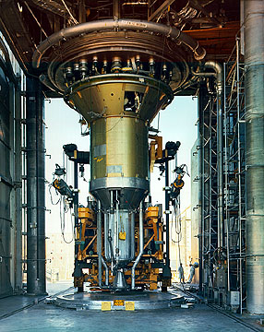

Fig.9 NERVA Engine[16]

The best parameters achieved in the nuclear tests were as follows:

|  |  |  |
| --- | --- | --- |
| Parameter | Reactor ID | Value |
| Power | PHOEBUS 2A | 4100 MWt |
| Peak Fuel Temperature (composite fuel) | PEWEE | 2750 K |
| Specific | PEWEE | 848 sec |
| Maximum Restarts | XE | 28 |
| Accumulated time at full power | NF-1 | 109 minutes |
| Continuous Operation | NRX-A6 | 62 minutes |

Table.7 Test Performance Record of ROVER Program[4]

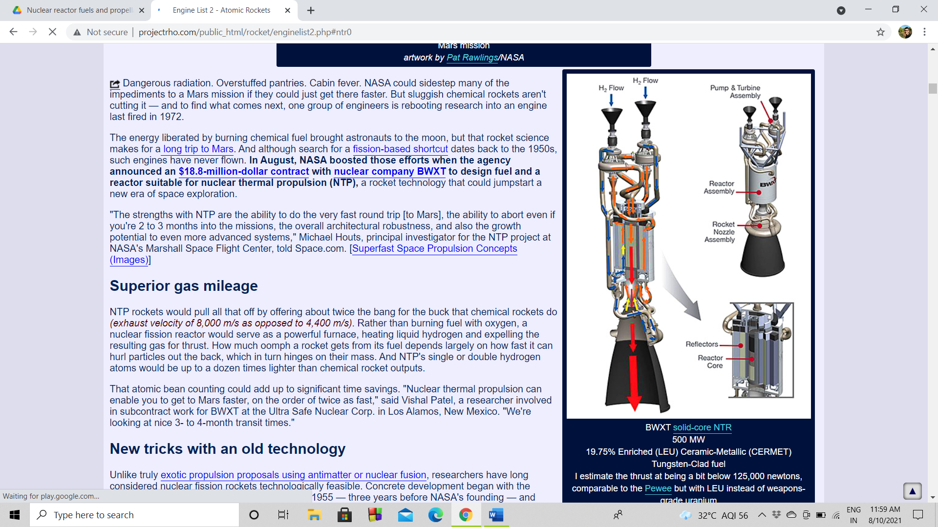

Fig.10 Solid Core Nuclear Thermal Rocket[5]

**6. Propellant**

For NTP operations, a propellant is the material which will be heated and expanded in the reactor chamber to be expelled at tremendous velocities to produce thrust.

**6.1. Selection Criteria**

Two criteria that are absolutely necessary for choosing the propellant are:

* low molecular mass since exhaust velocity is inversely proportional to square root of molecular mass.

[18]

* A non-corrosive propellant which will not react with nuclear fuel material.

Liquid Hydrogen fulfil 1st criteria with a molecular mass of 2.016, it can provide Isp values of up to 900s seconds. On the other hand, carbon monoxide, ammonia fulfil the 2nd criteria but have higher molecular weights giving Isp values of ranging from 200 s to 360 s [17] which a chemical rocket engine can provide thus decreasing the efficiency of NTP reactors. We have decided to go with liquid hydrogen in our primary analysis as it gives very high exhaust velocity hence improving the efficiency.

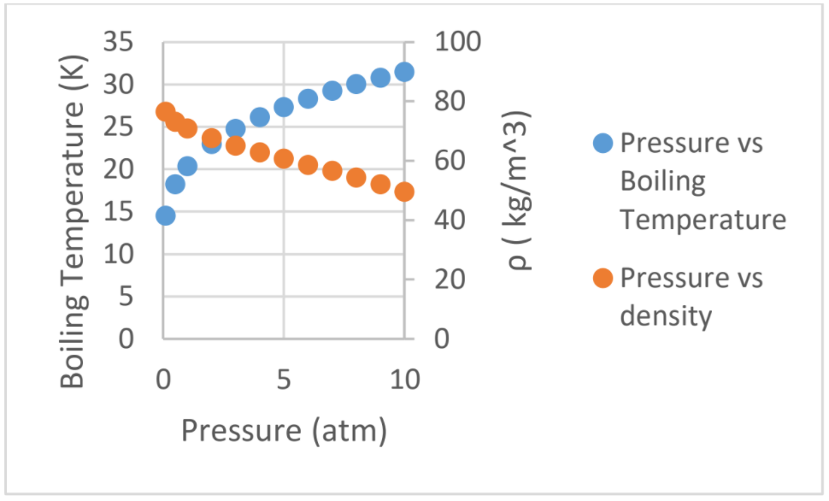

Fig.11 Liquid Hydrogen Properties[18]

Hydrogen has smaller range of temperatures to store in liquid form and its density decreases with increase in temperature. Active cryo-cooling mechanisms and in use and are further being developed by NASA to use LH2 in chemical and NTP rockets as well. Since our priority with NTP reactor rockets is to increase the efficiency of the propulsion system with higher Isp values. Corrosion due to hydrogen is minimized by the use of ZrC coating in the coolant channels and the reactor bed[4]. Even water as a propellant exhibit same corrosive nature at the high operating temperatures of the reactor[17].

Liquid hydrogen will be the best available option as

* It has highest Isp among all the other propellant options available and this will cancel out any additional cost that its increased volume might cause due to low density
* It can also be used as a coolant

**6.2. Mass approximation**

Using rocket equation,

Δ𝑽=𝑰𝒔𝒑∗ 𝒈𝟎∗𝐥𝐧(𝒎𝟎/𝒎𝒇)

**with ΔV being the change in velocity of a spacecraft necessary to travel to a destination,**

**Isp being the ratio of thrust to weight of fuel consumed,**

**g0 being Earth’s gravitational acceleration (9.81 m/s^2),**

**m0 being the initial mass of the craft before a burn,**

**and mf being the final mass of the craft after a burn.**

Taking ΔV = 0.854 km/sec

Isp = 900sec

And initial mass (M0) as 16.8 tonnes

We get,

Mass of propellant (Mp)= 1548.89kg

Keeping propellant margins of 5%

We get propellant mass (Mp) =1626.33 kg

|  |  |
| --- | --- |
| Mass of propellant | 1548.89 |
| Propellant margin | 5% |
| Final propellant mass | 1626.33 |

Table.8 Propellant Mass Details

**7. Storage**

Liquid hydrogen must be stored at minus 20k and handled with extreme care. To keep it from evaporating or boiling off (90k), rockets fuelled with liquid hydrogen must be carefully insulated from all sources of heat, such as rocket engine exhaust and air friction during flight through the atmosphere. Once the vehicle reaches space, it must be protected from the radiant heat of the Sun. When liquid hydrogen absorbs heat, it expands rapidly; thus, venting is necessary to prevent the tank from exploding. Metals exposed to the extreme cold of liquid hydrogen become brittle. Moreover, liquid hydrogen can leak through minute pores in welded seams.

**7.1. Material selection for tanks**

The material chosen for the propellant tanks is a titanium alloy namely Titanium Ti-6Al-4V. Its chemical composition includes of 6% aluminium, 4% vanadium, 0.25% iron(maximum), 0.2% oxygen(maximum), and the remainder titanium. This alloy is used as it is very light and strong at very high temperatures. Further, the titanium alloy has pretty high specific strength, good heat resistance, high corrosion resistance and so is an excellent candidate for the selection of materials used to manufacture the tanks



Fig.12 Ti-6Al-4V Mechanical Properties

**7.2. Cryogenic storage**

Cryogenic storage will be done in two stages, first stage is when there is lift off until the space craft reaches the higher earth orbit. In this stage there will be higher boil off and passive thermal control will be used for the cryogenic tanks. In the 2nd stage up to mars reverse Brayton cycle will start off which is a zero boil-off system.

Passive thermal control includes the combination of insulation, low-conductivity structure, mixing, and thermodynamic venting. – A protective blanket must be thick (>50 radiation shield layers resulting in 2 to 3 inches) for long duration missions in space to optimize the interface between the multilayer insulation (MLI) blanket and elements that must penetrate it such as structure and plumbing.

In the 1st stage we will use MLI up to 150 layers as that’s the maximum recommended layers.

The cryogenic storage of liquid rocket engine propellants for long-duration space exploration missions requires a focused effort towards eliminating the external heat inputs that contribute to the evaporation of the propellant, commonly referred to as boil-off. This cryogenic boil-off increases the vapor volume, also known as the ullage, within a cryogenic tank, while decreasing the volume of the liquid, thus reducing the amount of usable propellant while raising the internal pressure. Once tank pressure rises above the allowable limits, the tank contents must be vented to reduce the ullage mass and return the tank contents to an acceptable pressure. This vent case causes some loss of the propellant, which must be compensated for by carrying additional propellant on board, which in turn increases the mass requirements for a mission.

During the course of a mission, heat enters the walls of a cryogenic tank and transfers into the propellant, causing undesired boil-off of the liquid. However, if this heat can be intercepted before it enters the tank wall, the propellant can be maintained at a low enough temperature to prevent boil-off from occurring, thus achieving *zero boil off*.

We are using reverse turbo brayton cryocooler technology to achieve the zero boil off

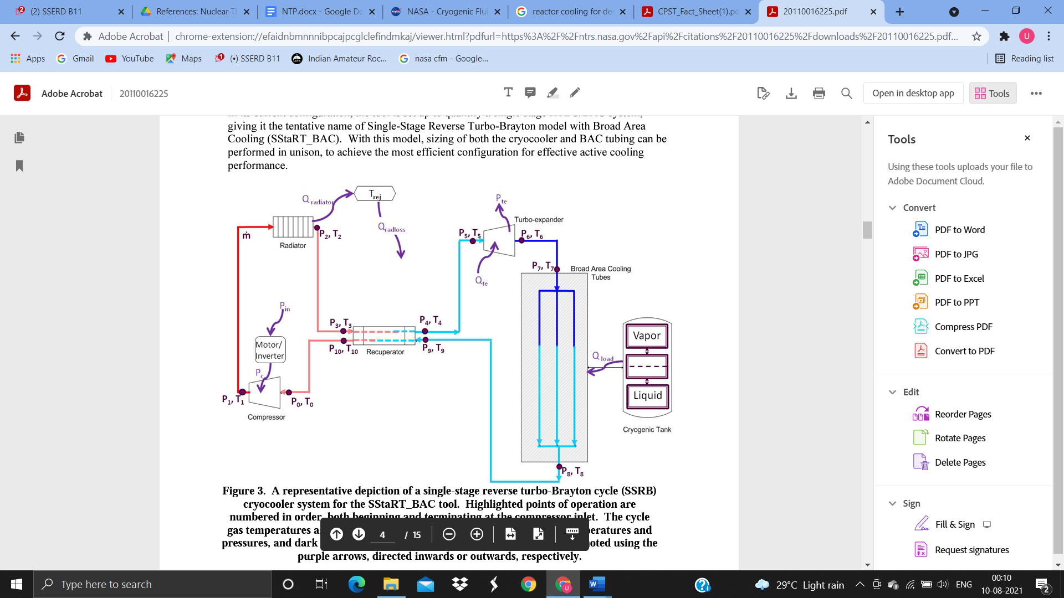

Fig.13 Reverse Turbo Brayton Cycle

The above figure indicates the reverse turbo brayton cycle. red indicates the highest operation temperatures and pressures, and dark blue shows the lowest. Energy inputs and outputs are noted using purple arrows, directed inwards or outwards

Turbo-Brayton cryocoolers are characterized by their low resonant vibration, flexible integration with spacecraft systems, ability to cool remote and distributed loads, their high technology readiness level (TRL) and its scalability to accommodate higher capacity lifts. These cryocoolers are excellent for long duration mission such as interplanetary mission

**8. Structure**

**8.1. Material selection for spacecraft bus**

All the major structural components use honeycomb sandwich panels with the core and facing skins both made of Aluminium-6061 T6. A material capable of withstanding the conditions expected with a suitable factor of safety while having low weight and cost. More important factors include high strength, high stiffness, low thermal expansion coefficient and electrically conductive outer layers. It must qualify the launch vehicle quasi-static loads as well as have sufficient natural frequency to avoid dynamic coupling with the launch vehicle. Further the factors influencing our selection criteria include avoiding buckling which can be induced by various types of loading including uneven distribution of masses on the side panels as well as thermal stresses, strength, ductility, young’s modulus, density, fracture toughness and damping. Keeping all these factors in consideration, Al 6061-T6 was chosen as the material for all major structural components of the spacecraft. 6061 T6 is a precipitation-hardened aluminium alloy, containing Silicon, Magnesium and Iron as its major alloying elements. 6061 T6 offers the best strength to weight ratio for the given cost range.



Fig.14 Al 6061 T6 Mechanical Properties

**8.2. Radiation shielding**

Assuming the NTP as a point isotropic source to make it independent of specific reactor design, the NTP will emit radiation uniformly in a sphere. This will cause the power of radiation that a medium sees to vary with distance from the NTP source as our propellant tanks will only see a fraction of the total surface area of this emitted sphere of radiation in a process called “geometric attenuation”. How this scaling works mathematically is by applying a solid angle fraction, which amounts to a ratio of the area of the sphere of radiation to the area of propellant tank the radiation is incident upon.

𝑅𝑒𝑎𝑐𝑡𝑜𝑟 𝑆𝑜𝑙𝑖𝑑 𝑎𝑛𝑔𝑙𝑒 𝑓𝑟𝑎𝑐𝑡𝑖𝑜𝑛 = 𝑇𝑎𝑛𝑘 𝑓𝑎𝑐𝑒 𝑎𝑟𝑒𝑎 = 4∗𝜋∗𝑆

The tank surface area =113 m^2

we can build a radiation shield using concrete Barium silicate cement can be used .it Shields gamma rays and X-rays, slows down fast neutrons .

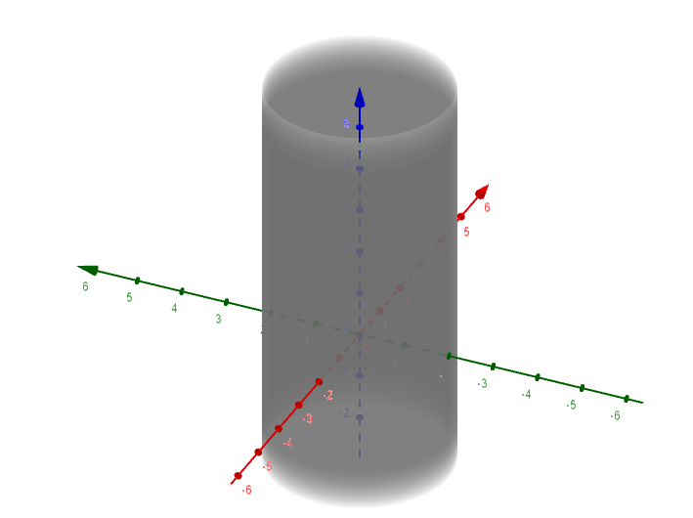

Fig.15 Storage Tank Visualization

A cement mix prepared from 60 wt-% barite, 25 wt-% kaolin and 15 wt-% calcined alumina and containing about 54 wt-% B2S and 33 wt-% mullite was chosen as the optimum mix for its compromise between good physicomechanical, sintering and refractory properties. Refractory castable samples prepared from 85 wt-% graded aggregate and 15 wt-% fine powder (,63 mm) of this mix show good mechanical, sintering and refractory properties.

**8.3. Nozzle**

We have decided to use a bell-shaped nozzle as it is most feasible in terms of manufacturing, easier to circulate coolant for cooling and also most used nozzle for space mission

* Exhaust Temp: Tex ~2650 - 2800 K
* Chamber Pressure: Pch ~1000 psi
* Nozzle Area Ratio: ε~300:1 to 500:1

Above data was taken from NASA DRA 5.0 case study

**8.3. Engine cycle**



Fig.16 Engine Expander Cycle

We chose expander cycle for our mission because the bleed cycle performance, measured as Isp, is lower than that of the expander cycle. In contrast to the bleed cycle, all the propellant is heated and expanded through the main propulsive nozzle. To improve bleed cycle performance, the turbine inlet temperature is raised to the maximum that can be obtained. This is limited by the materials structural and corrosion/erosion characteristics in the hot hydrogen environment. A comparison of bleed and expander cycle performance is shown in the Figure below. Also shown in the figure is the effect of turbine inlet temperature. At low turbine temperature the expander cycle is significantly higher in performance, but the difference is only 5-6 sec at the selected turbine inlet temperature of 2750 K

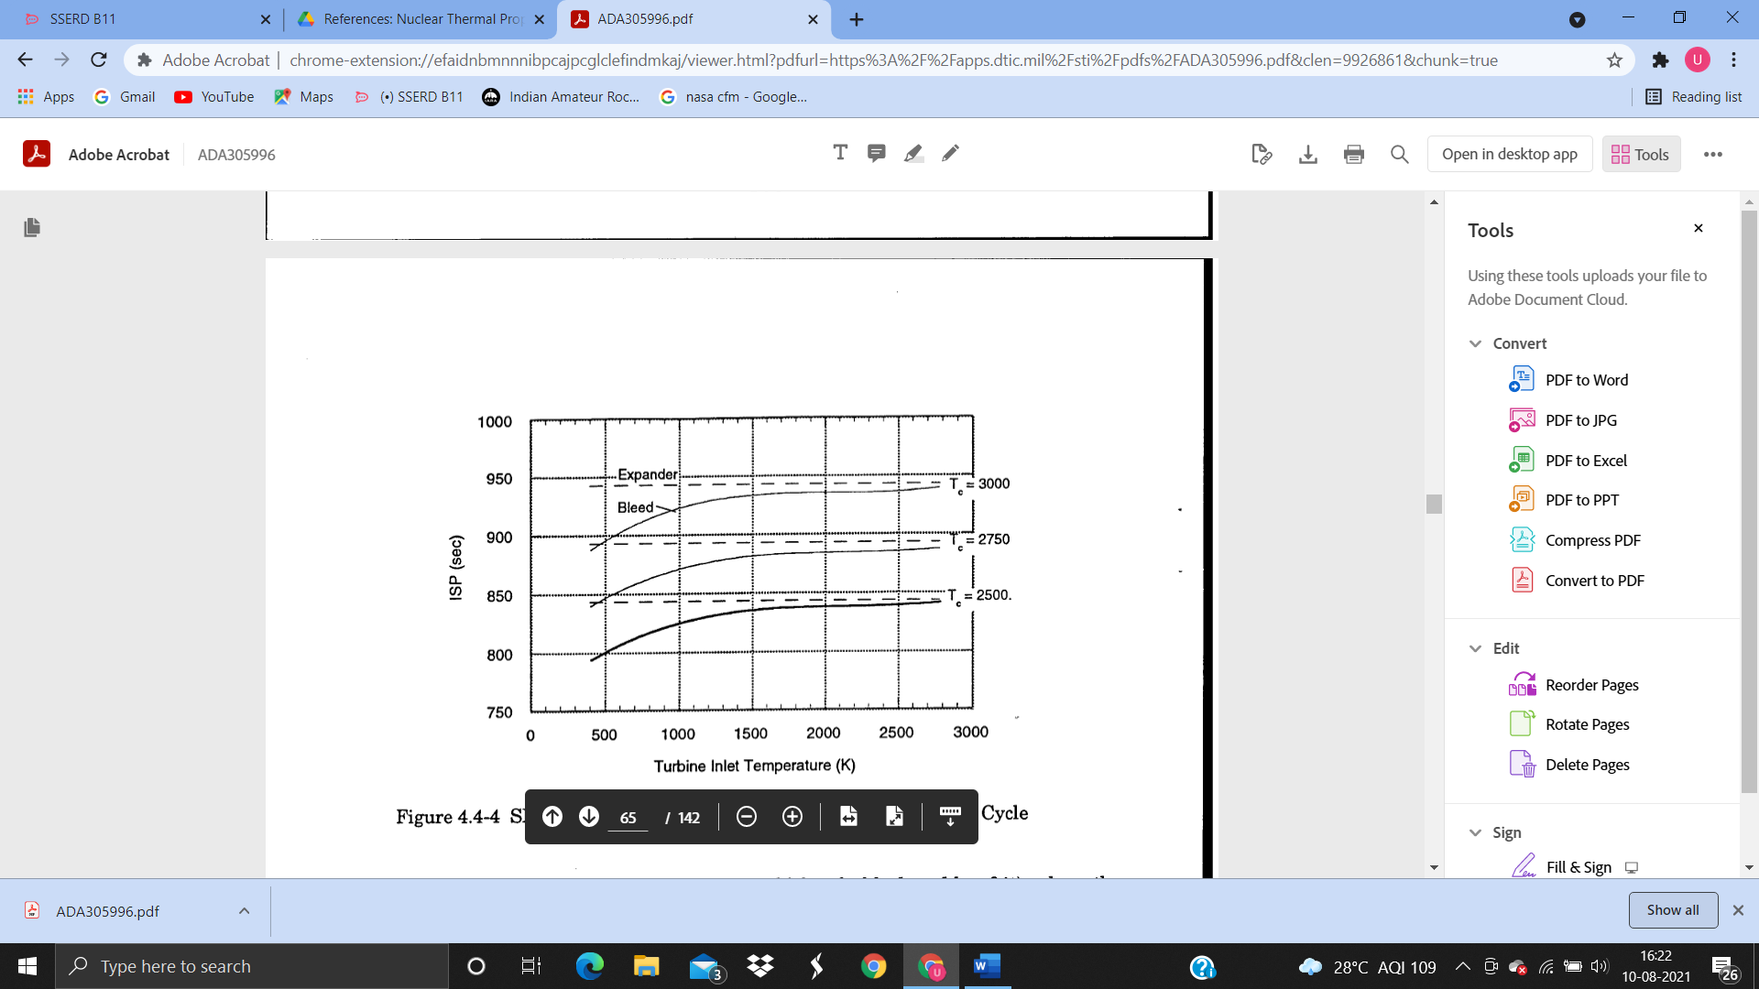

Fig.17 Expander vs Bleeder cycle Performance

**9. Cooling system**

Hydrogen serves as both the system coolant and engine propellant for our system. It is stored at approximately 20 K in liquid form in a pressurized, cryogenic ullage reservoir. A pump is used to pull liquid hydrogen from the reservoir and distribute it through the system’s cooling passages. When the rocket is operational and the core is critical, the hydrogen first passes over the exit nozzle where it undergoes a phase change to a gas while cooling the nozzle and preventing it from melting. The coolant is then fed up through the reflector drums towards the top of the core. After accumulating in an upper tie-tube plenum, the hydrogen is passed down through the core through the inner channel of a tie-tube. The conduit passes the hydrogen to a lower tie-tube plenum where the gas is passed back up through the outer layer of the tie-tube. The purpose of this two-fold pass through the core is to preheat the hydrogen for insertion directly into the fuel elements and to heat hydrogen to a point that can drive turbomachinery located at the top of the core. As the hydrogen passes out of the top of the tie-tube it is used to drive turbomachinery that drives the pump that initiates the entire coolant flow process.

**10. Conclusion**

Nuclear thermal propulsion is a very useful and efficient way for interplanetary missions in future. Due to high Isp it shortens the mission time considerably and also allows for a broader scope at launch window. Due to higher thrust than liquid propulsion NTP can also carry more cargo. Major concerns regarding NTP are the emission of radiation in atmosphere and health risk that it poses to the people involved. Other challenges include finding more efficient propellant as the current favourite liquid hydrogen corrodes materials at high temperature and also has very low density and low boiling point which challenges the storage capacity. The search is going on for methane and water to be used instead. While the research is going on about the propellant options, we also face challenges for cryogenic storage. Various techniques such as cryogenic liquid management (CFM) are under development.

Current studies by various agencies show that NTP can be considered as a potential propulsion system for inter-planetary missions in future. With advancement in technology and continuous research to improve its efficiency NTP will be best option for space travel in near future.

**11. References**

[1] 3D calculator. (n.d.). Retrieved August 12, 2021, from https://www.geogebra.org/3d?lang=en

[2] Akkurt, I., Akyıldırım, H., Mavi, B., Kilincarslan, S., & Basyigit, C. (2010). Radiation shielding of concrete containing zeolite. *Radiation Measurements,* *45*(7), 827-830. doi:10.1016/j.radmeas.2010.04.012

[3] Baker, D. (1971). Graphite as a neutron moderator and reflector material [Abstract]. *Nuclear Engineering and Design,* *14*(3), 413-444. doi:10.1016/0029-5493(70)90160-3

[4] Bhattacharyya, S. K. (2002). An assessment of fuels for nuclear thermal propulsion. doi:10.2172/822135

[5] ENGINE list 2. (n.d.). Retrieved August 13, 2021, from http://www.projectrho.com/public_html/rocket/enginelist2.php

[6] Falcon heavy. (2021, August 10). Retrieved August 13, 2021, from https://en.wikipedia.org/wiki/Falcon_Heavy

[7] Falcon heavy. (n.d.). Retrieved August 12, 2021, from https://www.spacex.com/vehicles/falcon-heavy/

[8] Guziik, M., & Tomsik, T. (2011). AN ACTIVE BROAD AREA COOLING MODEL OF A CRYOGENIC PROPELLANT TANK WITH A SINGLE STAGE REVERSE TURBO- BRAYTON CYCLE CRYOCOOLER. Retrieved August 12, 2021, from https://ntrs.nasa.gov/api/citations/20110016225/downloads/20110016225.pdf

[9] Guzmán, I., Granda, E., Acevedo, J., Martínez, A., Dávila, Y., & Velázquez, R. (2019, December 11). Comparative in mechanical behavior of 6061 aluminum alloy ... Retrieved August 12, 2021, from https://www.mdpi.com/1996-1944/12/24/4157/pdf

[10] Han, B., Zhang, L., & Ou, J. (2017). Radiation shielding concrete. *Smart and Multifunctional Concrete Toward Sustainable Infrastructures*. doi:10.1007/978-981-10-4349-9_19

[11] Haslett, R. (1994, December 31). Space nuclear thermal propulsion program. Retrieved August 12, 2021, from https://www.osti.gov/biblio/75921

[12] Khalil, N., & Zawrah, M. (2004). Self-formed mullite containing refractory barium silicate cements and their castable applications. *British Ceramic Transactions,* *103*(5), 223-226. doi:10.1179/096797804225018705

[13] Lyon, L. (1973). Performance of (u,zr)c-graphite (composite) and OF (U,ZR)C (carbide) fuel elements in the Nuclear FURNACE 1 test reactor. doi:10.2172/4419566

[14] Mars atmosphere and volatile evolution. (2015, June 21). Retrieved August 12, 2021, from https://en.wikipedia.org/wiki/Mars_Atmosphere_and_Volatile_EvolutioN

[15] Mars orbiter Mission. (2021, August 09). Retrieved August 12, 2021, from https://en.wikipedia.org/wiki/Mars_Orbiter_Mission

[16] NERVA. (2021, June 18). Retrieved August 13, 2021, from https://en.wikipedia.org/wiki/NERVA#/media/File:NTS_-_ETS-1_002.jpg

[17] Nikitaev, D., & Thomas, L. (2021). In-situ alternative propellants for nuclear thermal propulsion. *AIAA Propulsion and Energy 2021 Forum*. doi:10.2514/6.2021-3597

[18] TRADES on DENSIFIED propellant for nuclear Thermal propulsion. (2019, February 28). Retrieved August 12, 2021, from http://anstd.ans.org/NETS-2019-Papers/Track-2--Mission-Concepts-and-Logistics/abstract-28-0.pdf

[19] Widnall, & Peraire. (2008). Orbit transfers and interplanetary trajectories. Retrieved August 12, 2021, from https://ocw.mit.edu/courses/aeronautics-and-astronautics/16-07-dynamics-fall-2009/lecture-notes/MIT16_07F09_Lec17.pdf